**GENETICALLY MODIFIED ORGANISMS (GMOS)**

**Genetically Modified Organisms (GMOs) are organisms whose genetics have been manipulated artificially (using genetic engineering techniques) in a way that doesn’t occur naturally via recombination or natural breeding process for making a certain change in their morphology, physiologies, and/or biochemistry.**

It can also be described as organisms in which foreign genes or genes have been introduced into their genome in such a way that the introduced foreign gene/genes remain stable and encode for the production of specific gene products (proteins). The USDA (United State Department of Agriculture) also adds that GMOs must have inheritable changes in their genetics and has broadened the definition of GMOs.

Table of Contents

* [History of Genetically Modified Organisms (GMOs)](https://microbenotes.com/genetically-modified-organism/#history-of-genetically-modified-organisms-gmos)
* [Process of Development of Genetically Modified Organisms (GMOs)](https://microbenotes.com/genetically-modified-organism/#process-of-development-of-genetically-modified-organisms-gmos)
  + [1. Direct Transfer](https://microbenotes.com/genetically-modified-organism/#1-direct-transfer)
  + [2. Use of Vector](https://microbenotes.com/genetically-modified-organism/#2-use-of-vector)
  + [3. Direct Editing of Existing DNA](https://microbenotes.com/genetically-modified-organism/#3-direct-editing-of-existing-dna)
* [Regulations and Controversies of Genetically Modified Organisms (GMOs)](https://microbenotes.com/genetically-modified-organism/#regulations-and-controversies-of-genetically-modified-organisms-gmos)
* [Positive Impacts of Genetically Modified Organisms (GMOs)](https://microbenotes.com/genetically-modified-organism/#positive-impacts-of-genetically-modified-organisms-gmos)
* [Negative Impacts/Associated Risks of Genetically Modified Organisms (GMOs)](https://microbenotes.com/genetically-modified-organism/#negative-impactsassociated-risks-of-genetically-modified-organisms-gmos)
* [Use of Genetically Modified Organisms (GMOs)](https://microbenotes.com/genetically-modified-organism/#use-of-genetically-modified-organisms-gmos)
* [List of Common Genetically Modified Organisms (GMOs)](https://microbenotes.com/genetically-modified-organism/#list-of-common-genetically-modified-organisms-gmos)
* [References](https://microbenotes.com/genetically-modified-organism/#references)

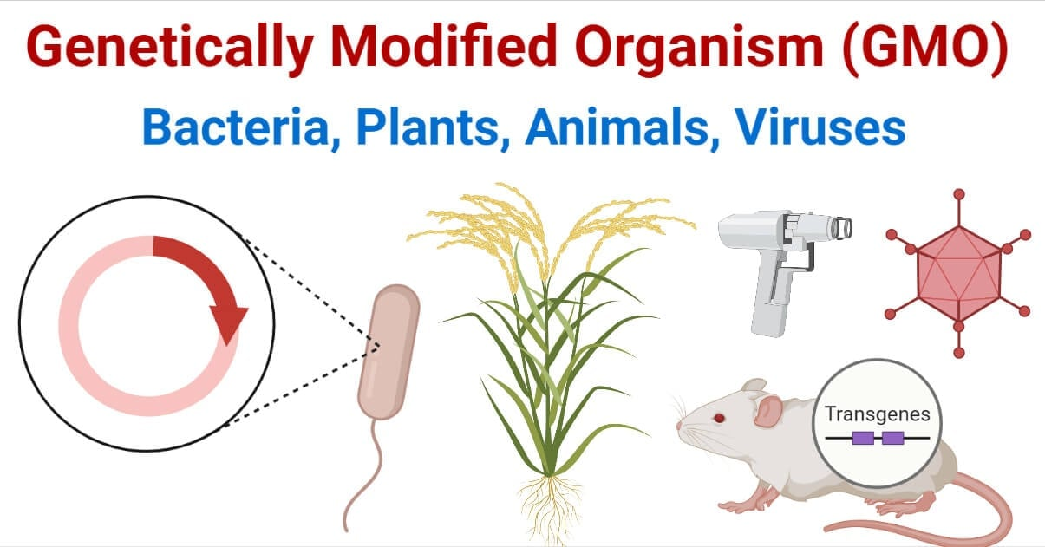

GMOs, however, do not include all genetically engineered organisms because genetically engineered organisms may have genes that are not functional or the changes may also occur naturally. Genetically engineered organisms include all organisms whose genome has been manipulated artificially.

GMOs are taken as one of the revolutionary technological advancements in the field of biology (genetics/biotechnology). Recently, a wide variety of plants including crops, flowers, and other medicinal and decorative plant species, animals, and microorganisms are genetically modified. Talking about GMOs, genetically modified plants, especially genetically modified crops strike our mind first. This is because genetically modified crops have gained a huge and direct application in our life.

Though scientists and companies producing GMOs are claiming GMOs as invaluable and revolutionary scientific achievements destined to change our economy, agriculture, and other bio-production depended on sectors, a significant number of experts describe GMOs as a disastrous scientific error with the potential to destruct nature and the natural balance of lives.

**History of Genetically Modified Organisms (GMOs)**

* In the year **1973**, biochemists **Herbert Boyer** and **Stanley Cohen** for the first time cut a kanamycin-resistant gene from one bacterium and inserted it into a plasmid of another bacterium transferring the kanamycin-resistant trait. This was the first genetically modified organism developed by mankind. Soon, in 1974, they transferred a gene from a toad species, *Xenopus laevis*, into a bacterium making the first GMO with genes from another kingdom.
* In **1977, GM *E. coli*** species capable of encoding human insulin hormone was developed by **Genetech**company, the first GMOs producing company. In **1978**, the company announced their GM *E. coli* species capable of producing insulin which they name “**Humulin**”. The US FDA approved the use of humulin in **1982** and it became the first product from GMO to be used for consumption.
* The first GMO in the animal kingdom was a mouse. **Rudolf Jaenisch** first created a transgenic mouse in **1974**, but a GM mouse with heritable characters was first developed in **1984**.
* The first GM plant was an antibiotic-resistant tobacco plant, developed in **1983** by transforming antibiotic-resistant genes through *Agrobacterium* *spp*.
* In the year **1988**, a genetically modified strain of *Pseudomonas syringae* was released into the environment for the first time.
* Genetically modified virus-resistant tobacco plant was the first GM crop cultivated commercially. It was produced and cultivated by China in **1992**.
* The first GM food to be approved and cultivated was a genetically modified tomato, called **the Flavr Savr**, produced by an American agriculture biotechnology and agrochemical company Monsanto.
* The first GM animal to be approved and used as food is **AquAdvantage Salmon fish**. It was approved for consumption in **2015.**
* Since these early developments of GMOs, a large number of plants and animals have been genetically modified. Mainly plants have been genetically modified and are being widely used as cash crops or food crops globally.

**Process of Development of Genetically Modified Organisms (GMOs)**

GMOs are produced by inserting foreign genes with some valuable trait into a certain organism. The whole process is multi-step including the selection of a certain trait and the trait-containing organism, isolating the gene encoding that trait, labeling the gene with marker, promoter, and terminator gene/sequence, and injection of the gene into the host’s genome.

There are three basic methods of transferring the selected labeled genes into target organisms, viz.:

**1. Direct Transfer**

Direct transfers of [gene](https://microbenotes.com/gene-a-comprehensive-guide/)/[DNA](https://microbenotes.com/dna-deoxyribonucleic-acid/) are common and simple techniques but have low efficiency and success rate. DNAs or genes are first edited or labeled before transferring. Genetically engineered and/or coated DNAs/ DNA fragments are delivered to gametes, seeds, or developing embryos by several techniques like bombarding with pressurized helium, electroporation, microinjection, heat shock, etc.

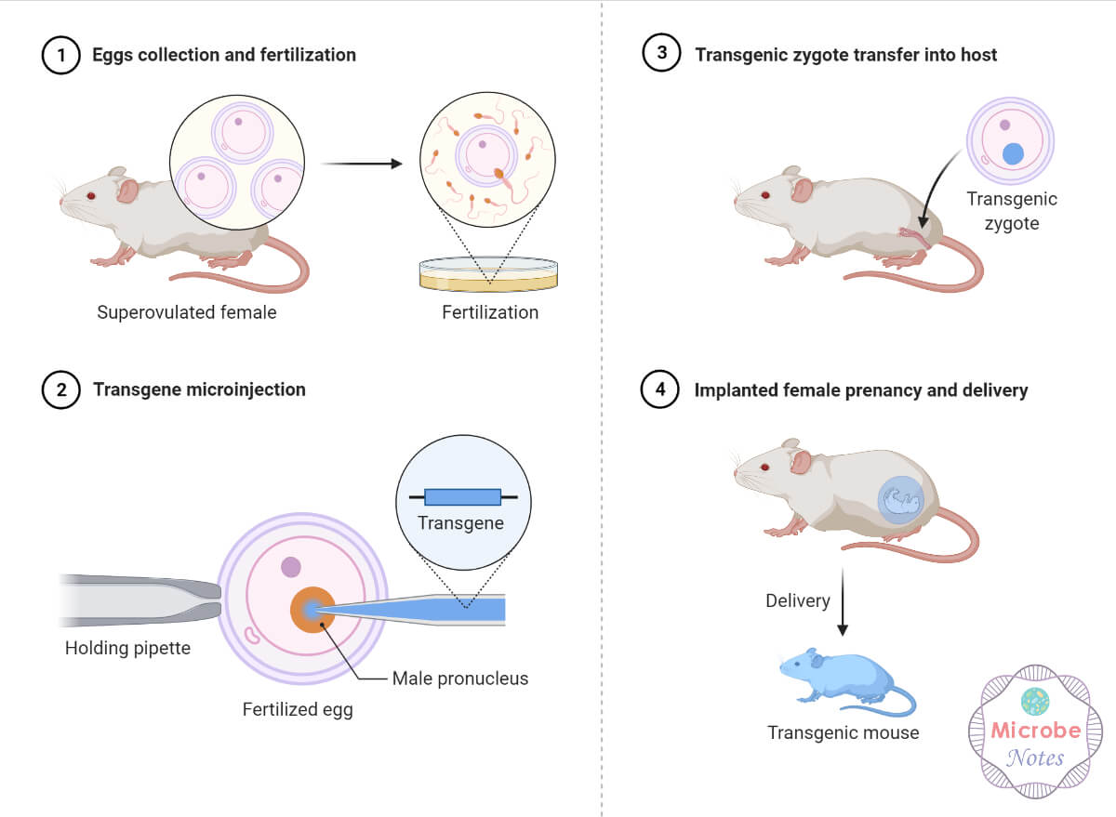Transgenic Mice Production-Microinjection

**2. Use of Vector**

Several viral or bacterial species are used as vectors to transfer genes into the target organism’s genome. *Agrobacetrium*-mediated recombination, viral recombination, phage-mediated recombination, etc. are commonly used to transfer genes using vectors.

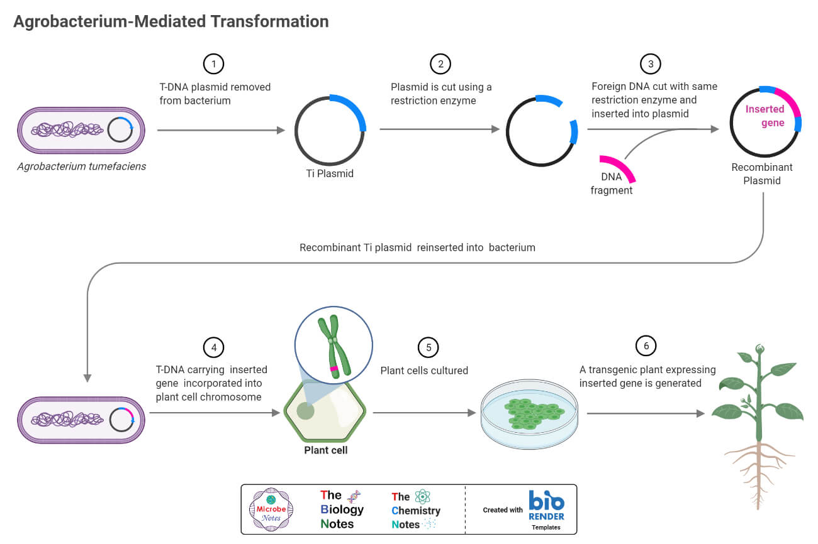Agrobacterium Mediated Transformation

**3. Direct Editing of Existing DNA**

After the development of gene editing and gene targeting tools like CRISPR-Cas9 and nucleases associated gene editing techniques like TALEN (transcription activator-like effector nucleases) are used in editing the genome of the target organism and modifying the genome to produce certain traits.

**Regulations and Controversies of Genetically Modified Organisms (GMOs)**

* Genetic modification of organisms with evil intentions is also possible and if such steps are taken with criminal intent, then the whole living system must suffer the consequence. For instance, GM viruses and bacteria with increased pathogenicity and virulence, GM pests with increased infestation rate, GM animals predating useful native species, GM vectors with enhanced disease transmission capacity, etc. will bring catastrophic effects. Hence, to prevent such demonic actions, genetic modification strictly abides by the laws of every nation. It is mandatory to take permission before genetically modifying any organism, and/or using GMOs for cultivation, commerce, or food.
* Although GMOs are considered a scientific breakthrough having possibilities to solve the problem of population growth and food crisis, reduction in arable land, the demand for the off-season, alien, hybrid, and nutrition-enriched food, etc., a large number of experts, environmentalists, theist, and naturalists believe that artificially meddling with natural gene flow invites a great risk in natural laws, ecosystem, and whole living system. Till now no such effects are observed; however, there is a huge controversy in the idea that GMOs only have pros and don’t affect the natural system of life.

**Positive Impacts of Genetically Modified Organisms (GMOs)**

* **Higher Crop Yields Meeting Increasing Demand for Food**; Genetically modified crops have their genetics optimized for higher yields. Crop production can be increased and the duration for fruiting to maturation and harvest can be reduced by modifying their genome.
* **Higher Income from Agriculture:** GM crops and animals produce higher yields and the products are consistent and of superior quality. These will increase the income from agricultural products.
* **Optimization in Use of Available Cultivable Lands:** GM crops are modified in such a way that they can thrive in harsh environmental conditions like rocky soils, deserts, land with low precipitation rates, saline areas, extreme cold or hot areas, etc. Thus, available lands with such harsh environments can be utilized.
* **Supply of Essential Nutrients via Modification of Components of Foods**: Several strains of GM crops, mushrooms, and animals are incorporated with essential vitamins, unsaturated fatty acids, cellulose fibers, and amino acids encoding genes and probiotics. Consumption of food from such sources supplies essential nutrients to consumers.
* **Improvement in Food Processing and Storage**: Some GM foods are modified in such a way that their ripening process is reduced and their stability in normal to some higher temperatures is optimized. These have facilitated easy transportation, post-harvest processing, and longer storage and shelf-life. This will not only facilitate agricultural trade and transport, but also consumers can use food for long duration and even in off-seasons.
* **Production of Pharmaceuticals**: GM organisms, especially bacteria and fungi and some plants are used in the production of hormones, enzymes, antibiotics, and metabolites of pharmaceutical value. GM medicines for the treatment of chronic diseases like diabetes, hypertension, genetic disorders, etc. are available for use and some are in the process of development. GKM viruses are used for vaccine production.
* **Reduction in Demand and Use of Harmful Pesticides and Insecticides**: GM crops and animals are modified to be resistant to several diseases and pests. This will reduce the need for harmful chemicals for treatment and prevention.
* **Preparation of Suitable Vectors for Biotechnology Research**: Viruses are genetically modified as vectors to insert genes in other organisms’ genomes. GM bacteria are also used as vectors in plant biotechnology.
* **Production of Foods during Off-seasons**: GM crops and animals can be grown in the off-season. This will make the supply of food even during off-seasons.
* Several GM plants and animals are used for decorations. Bio-luminescent plants and animals have gained popularity for decoration.

**Negative Impacts/Associated Risks of Genetically Modified Organisms (GMOs)**

* **Un-natural Gene Flow causing Destruction in Natural Laws resulting in Calamities**: Anti-GMOs group of people describe unnatural gene flow as the main problem with the development of GMOs. They fear that the production of GMOs breaks natural laws inviting natural calamities.
* **Possibility of Food Toxicity and Allergy**: The unnatural proteins encoded by inserted genes may be allergic and/or toxic to consumers. Although such cases haven’t been reported yet, this is also a high probability that the inserted gene/s mutates and encodes mutated proteins that can either be toxic or allergic.
* **Risk of Genetic Hazards**: Artificially inserted genes in a certain population disrupt the natural gene flow and can induce genetic hazards. If the inserted genes, like pest or disease-resistant genes, transform into genetically related species, the gene pool of that ecosystem may change.
* **Effect on Non-GMOs**:  GMOs don’t need pesticides and insecticides as they are innately resistant. Hence, there will be a reduction in the use of such agrochemicals. This will make the native non-resistant species more vulnerable to pests and insect infestation. Similarly, other plant species which used to depend on agrochemicals supplied to native crops will also be affected when we reduce the use of such chemicals.
* **The outgrowth of Native Species and Imbalance in the Ecosystem:** Due to higher yield and disease resistance, people are now using GMOs instead of native species making the native species endangered or rare. Similarly, GMOs can be cultivated in foreign locations and even during the off-season. This will disturb the biodiversity and biological balance of that place disrupting the whole ecosystem, food chain, and inter-species relations.
* **Selection of Resistant Species:** Insertion of GMOs resistant to pests, insects, or diseases endemic to that region will make the native non-resistant species the only available hosts. Hence, the native species will be highly affected leaving only the resistant species viable.
* **Disruption of the Food Web**: The introduction of foreign GMOs in a place will replace the native species of that place. Hence, the heterotrophs depending upon the native species for their food will be affected. This effect on the lifestyle and food source of one species will create a domino effect disturbing the whole food chain of that ecosystem.
* **Antibiotic Resistance**: Frequent uses of antibiotic-resistant genes are genetic markers during the production of GMOs that can cause the dissemination of antibiotic-resistant genes in the environment.

**Use of Genetically Modified Organisms (GMOs)**

1. **In agriculture**

GM organisms as high yielding, disease and pest resistant, and more adjusting in drastic environments crops and domestic animals

1. **In medicine**

Antibiotics, antibodies, hormones, enzymes, proteins, fatty-acids, amino acids, probiotics, minerals, and vitamins producing/containing products are produced from several GMOs.

1. **In Biotechnological Companies and Research**

GMOs are used in scientific research and biotech companies as vectors, model organisms for producing certain traits or compounds, etc.

1. **In recreation/decoration**

GMOs are vivid and more attractive as they are genetically modified to enhance their aesthetic value.

1. **In scientific research**

Several organisms are genetically manipulated and used in research, to prove several hypotheses, to research novel therapeutics, etc.

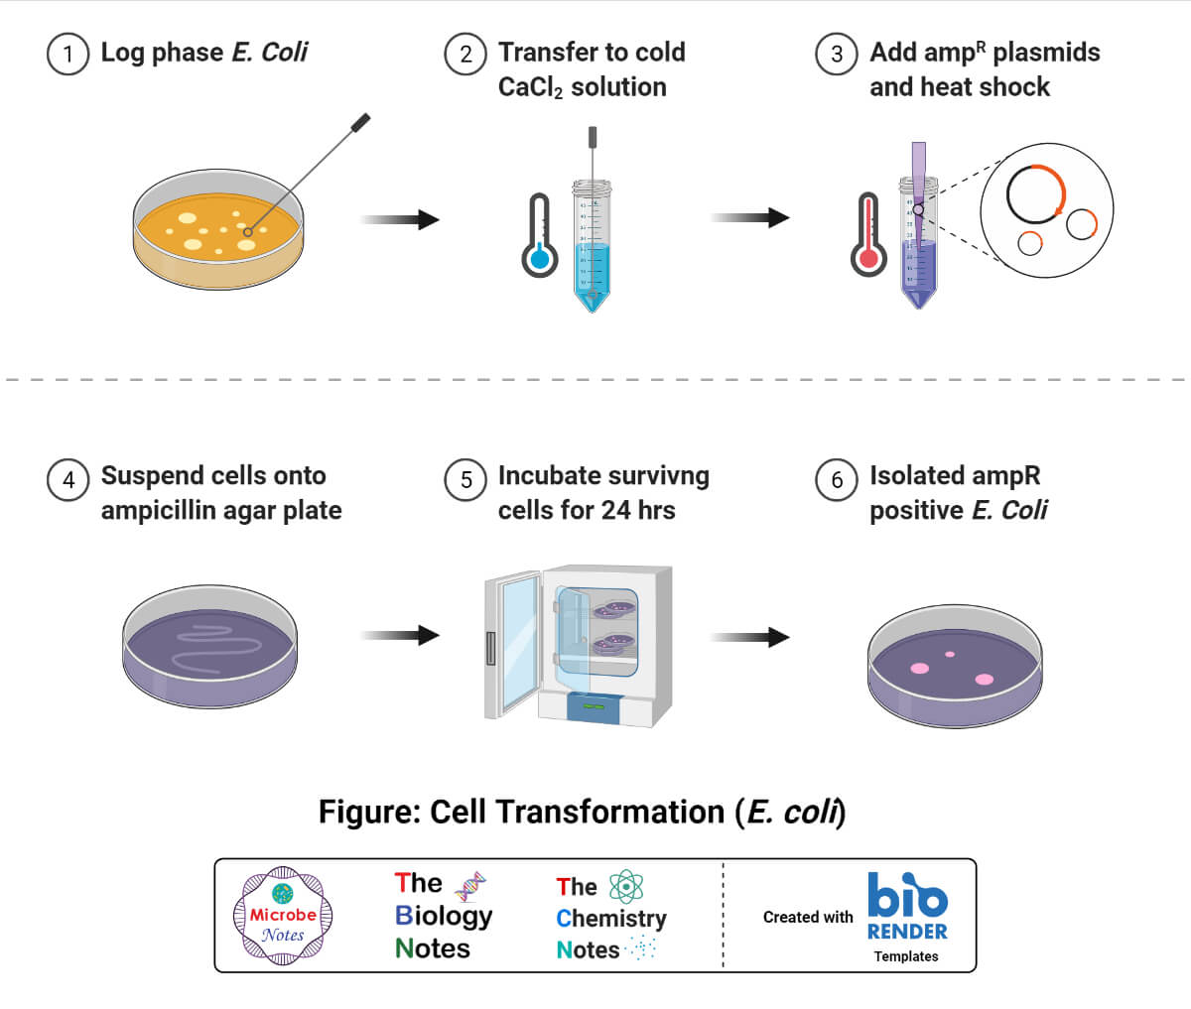

**List of Common Genetically Modified Organisms (GMOs)**

|  |  |
| --- | --- |
| **Name of Organisms {Name of GMOs}** | **Genetically Modified Traits** |
| Canola (*Brassica napus* subspecies) {Laurical™Canola, InVigor™Canola, Phytaseed™Canola, Navigator™Canola, etc.} | Modified fatty acids Herbicide and antibiotic resistance Male sterility Increased yield, etc. |
| Bean (*Phaseolus vulgaris*) | Viral disease resistance |
| Eggplant (*Solanum melongena*)  {BARI Bt Begun-1, -2, -3 and -4} | Insect and antibiotic resistance |
| Potato (*Solanum tuberosum*)  {Atlantic NewLeaf™potato, Starch Potato, NewLeaf™Y potato, New Leaf™Plus Russet Burbank potato, etc.} | Insect and antibiotic resistance Modified sugars/carbohydrates Viral disease resistance Reduced acrylamide potential |
| Soybean (*Glycine max*)  { Liberty Link™soybean, Optimum GAT™, Genuity®Roundup Ready™ 2 Xtend™, Genuity®Roundup Ready™ 2 Yield™, etc.} | Modified fatty acids Herbicide and antibiotic resistance Drought stress tolerance Insect resistance |
| Sugar Beet (*Beta vulgaries*)  { InVigor™sugarbeet, Liberty Link™sugarbeet, etc.} | Drought stress tolerance Herbicide resistance Viral disease and antibiotic resistance |
| Sugarcane (*Saccharum spp*.) | Drought stress tolerance Herbicide resistance |
| Tomato  (*Lyopersicon esulentum*)  { FLAVR SAVR™, etc.) | Insect resistance Delayed ripening and fruit softening Viral disease resistance |
| Papaya (*Carica papya*)  { Huanong No. 1, SunUp, etc.} | Viral disease resistance |
| Apple (*Malus domestica*)  { Arctic™“golden Delicious” Apple, Arctic™“Granny Smith” Apple, etc.} | Non-browning Antibiotic resistance Viral disease resistance |
| Maize (*Zea mays*)  { Enogen™, Agrisure®Duracade™, Starlink™Maize, Enlist™Maize, Bt Xtra™Maize, Genuity®DroughtGard™, etc.} | Fertility restoration and male sterility Modified amylase Multiple insect resistance Herbicide tolerance Drought stress resistance |
| Rice (*Oryza sativa*)   { Liberty Link™rice, Huahui-1, Huahui-1, etc.} | Insect resistance Drought resistance Herbicide-tolerant Anti-allergic  Incorporated vitamins |
| Goat, chicken, salmon fish, pig | Production of medicinal components Increased growth in unfavorable climatic conditions |